Study Tour 2019
Department of English
Linguistic Landscapes in the Contemporary South Korea

The Study Tour is an annual overseas learning activity organized by the Department of English. It aims to develop students’ understanding of intercultural communication practices in the globalized context and to equip them with knowledge about diverse cultures in a country where English is used as a lingua franca and plays a significant role in various domains. The destination chosen for the tour for 2019 is South Korea. The overarching theme is Linguistic Landscapes in the Contemporary South Korea. To explore the theme, students will participate in a variety of guided learning activities including a two-week course at the Hankuk University of Foreign Studies in Seoul. Students will also participate in cultural classes and excursions as well as conduct field research about the use of English as a lingua franca in four cities: Seoul, Busan, Gyeonju and Jeju City (see the itinerary on p.4). Upon successful completion of the tour, students will gain three credits for EN 3584 Professional Communication Summer Programme or EN 3577 Creative and Cultural Summer Programme. (Refer to the following guidelines for more details and application procedure.)

Guidelines
Course details & requirements
- EN3577 (Creative and Cultural Summer Programme*) and EN3584 (Professional Communication Summer Programme*) are 3-credit courses, which offer students an option of learning through Study Tour or Summer School.
- The Study Tour coordinator is Dr. Becky KWAN and the tour leader is Dr So-yeon AHN.
- There will be two parts to the tour. Students will spend the first two weeks attending daily 2-hour seminars or workshops on language and communication issues at Global University-Industry Support Center, Hankuk University of Foreign Studies (weekends excluded). This will be followed by 10-12 days of field-trips/excursions (by coach/train) to various towns and the final destination will be Jeju where students will take the flight back to Hong Kong.
- Students are not allowed to take separate flights, stay behind or leave the group without prior approval by the tour leader.
- Course assessment will include short in-class assignments, a group project report and one piece of reflective writing.
- Students will be automatically registered for the course in Summer 2019 if their applications are successful.

Application procedures
- Students who are interested in joining the Study Tour should complete and submit the application form provided at the end of this flyer to Ms Queenie Wong in the General Office by 28 February 2019.
- The application should include a HK$5,000 deposit cheque made payable to "City University of Hong Kong" with your name, student ID, and phone number written on the back.
- The participant list will be announced in March 2019. For successful applicants, this deposit will be put toward the cost of the study tour as the 1st instalment of the programme fee. For unsuccessful applicants, the cheque will be returned.

Programme cost & fee
- 60% of the programme cost will be sponsored by the Global Experience for All Funding Scheme (GEAFS) whereas 40% will be borne by students.
- After sponsorship, the expected programme fee is around HK$12,000. This amount is not finalized, but it will be close to this estimation. The finalized amount will be confirmed at least one month before the trip.
- The programme fee will be collected in two instalments: 1st instalment ($5,000) submitted together with your application (i.e., the deposit); 2nd instalment (the remainder) submitted at least one month before the trip.
- The programme fee will cover return flight tickets, accommodation, inter-city ground transportation, tuition at Hankuk University of Foreign Studies, cultural events and some meals. Students are expected to prepare some cash to support your own expenses, some local transportation (city buses and subway) and some optional activities.
- All participants will be automatically covered by CityU’s insurance package “Group Travel Insurance”. However, students are advised to get additional insurance coverage from any insurance companies. You are advised to check the details from FO’s website before making any arrangement.
- Please note that the programme fee is calculated based on the group size. Students will be held accountable for the headcount once your application is successful. Any surcharge, loss, or additional cost caused by individual cases such as drop-out, absence/late, or damage shall be borne by the corresponding students (e.g. if you drop out of the tour, you still have to pay the programme fee).

Travel document & visa
- Successful participants need to submit a copy of your passport and ID card for flight-/accommodation-booking.
- You should check and make sure you have a valid passport and apply for a visa (supporting documents will be issued upon request).
- Countries with visa-free entry for passport holders are shown : http://english.visitkorea.or.kr/enu/TRV/TV_ENG_2_1.jsp
- The cost of any travel document or visa shall be borne by individuals.

Scholarships
- Students from the Department of English with academic merits and genuine financial needs supported by relevant and valid proof may apply for the EN Scholarships for Overseas Learning Activities. Each awardee will receive HK$5,000 after fulfilling the scholarship requirements. For enquiries, please contact Miss Queenie Wong about the scholarships.

Tentative schedule of learning activities
Time: July 21- August 17
Week 1-2 Seoul | A short course  Students will attend a short course (2 hours per day) at the Hankuk University of Foreign Studies*. The course aims to develop students’ understanding of intercultural communication practices in the globalized context. The course will also provide students for the field research they will conduct in the rest of the trip. Topics to explore in the course include the following about Korea: popular culture, Internet and social media, English education, globalization strategies of the government, and English as a lingua franca.  Cultural classes and excursions  Students will participate in extra-curricular activities to explore the history and culture of Korea.  Field trips  Students will visit various sites to collect data for the field research to explore the use of English in Korea.
Week 3-4 Gyeonju, Busan and Jeju | Field trips  Students will continue their data collection for the field research by visiting various sites.  Excursions  Students will join excursions to some of the historic, educational and natural sites.
Itinerary:

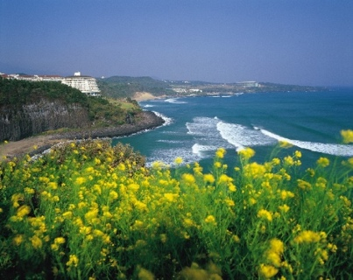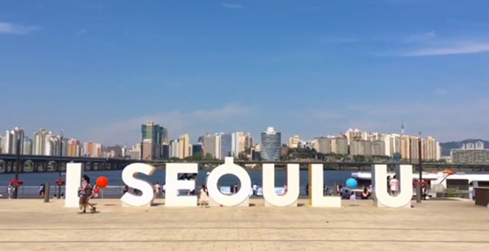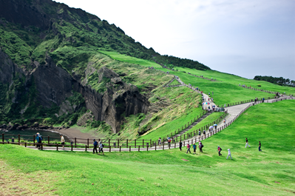

Study Tour 2019 Application Form
Please complete and submit this paper form to Ms Queenie Wong in the General Office by 28 February 2019. Your application should include a HK$5,000 deposit cheque made payable to "City University of Hong Kong" with your name, student ID, and phone number written on the back. For successful applicants, this deposit will be put toward the cost of the study tour as the 1st instalment of the programme fee. For unsuccessful applicants, the cheque will be returned.
PART A - Personal Particulars
General information
Full Name: |  |  |  | Gender: |  | M / F
Student ID: |  |  |  | Date of birth:
Programme : |  |  |  | CGPA:
Cohort: |  |  |  | Stream of study :
Expected graduation time : |  | Month Year |  | Department :
Phone number: |  |  |  | Email:
Home address
Emergency contacts
Name: |  |  | Relationship with applicant: |  |  |  | Phone:
Name: |  |  | Relationship with applicant: |  |  |  | Phone:
Travel document
HKID No.:
Passport No.: |  |  |  | Visa/entry permit no.(if applicable):
Expiry Date: |  |  |  | Nationality:
 |  | Signature |  |  |  | Date

PART B – Supplementary question

In what ways do you think you would benefit from the 4-week intensive programme? How has your experience and/or coursework prepared you for this type of intensive learning experience? (Maximum 300 words; to be completed by all applicants.)

